

Honeycomb elbow brace

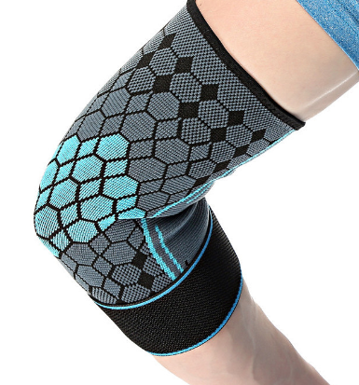

Item No: E05

Material: Polyester

Size:S M L

Color: Black,Orange,Blue,Green,Red

Packing: 1 piece / opp bag,200 pcs/carton

The elbow pads are made of nylon, spandex, elastic and reinforced with straps.Stabilize the elbow, disperse the pressure of the elbow joint, reduce muscle tremor, and keep the skin comfortable and dry. Safe and professional sports elbow pads will protect you during exercise and improve your sports performance.

**Common Examples of Use**

Running, fitness equipment, fitness and bodybuilding, cycling,table tennis, badminton and tennis sports, other ball sports.

**Product Features**

Elastic lock edge, professional elastic edging, comfortable to wear, not easy to slip down.

Breathable and comfortable knitted fabric, soft and elastic, comfortable and fit.

Multiple pressure, using straps for pressure, adjustable tightness, pressure protection.

**Size Chart**

