

Adjustable compression elbow pads

Item No: E04

Material: neoprene

Size:one size fits all

Color: Black,Red

Packing: 1 piece / opp bag,150 pcs/carton

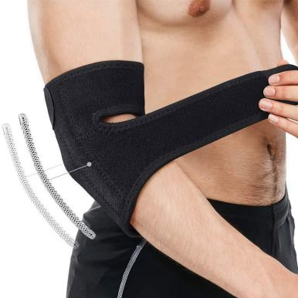

Adjustable Compression Elbow Support provides moderate support and adjustable compression for weak, sore or injured joints.Easy-to-use adjustable features offer customizable compression, support and fit for use during a variety of activities.

**Common Examples of Use**

Fitness, cycling, hiking and camping

**Product Features**

Spring support, stable pressure.

Perforated fabric, skin-friendly and breathable design.

Firm Velcro, freely adjustable size.

**Size Chart**

