

Basketball elbow brace straps

Item No: E02

Material: neoprene

Size:one size fits all

Color: Black,Blue,Red

Packing: 1 piece / opp bag,500 pcs/carton

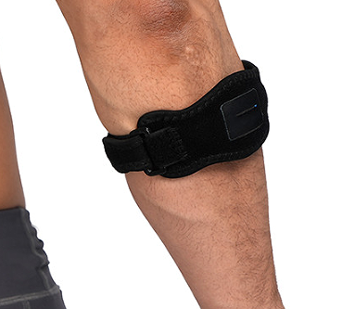

To the small arm and elbow timely protection movement. reduce accident movement.wrapping design breathable,sweat from dredging exclusion, keep comfortable.

**Common Examples of Use**

Running, Cycling, Sports Protective Gear Accessories, Football, Basketball, Volleyball, Table Tennis, Badminton, and Tennis

**Product Features**

Shock adsorption buffer:Damping gasket

Pressure adjust:Strong regulation lock

Breathable edge wrap

**Size Chart**

