

Multi-position free heat compress wristband

Item No: A07

Material: Neoprene

Size:one size fits all

Color: Black

Packing: 1 piece / opp bag,200 pcs/carton

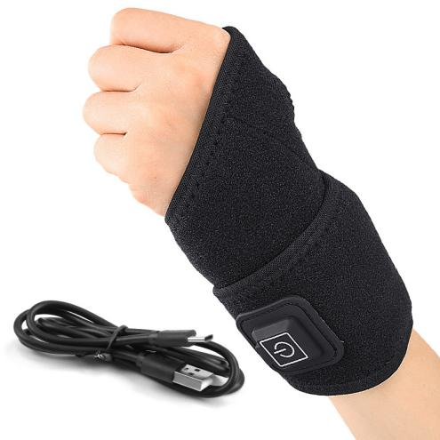

This product is made of OK cloth and neoprene. It is a USB electric heating wrist guard that can provide heat to multiple parts of the body, including hands, elbows, ankles, and soles of feet. It meets the needs of daily life.

**Common Examples of Use**

Office,Home

**Product Features**

Easy to move, multiple scenes, use USB interface, hot compress anytime and anywhere.

One-touch temperature adjustment, three-speed temperature control, one-touch start, simple operation, even the elderly can use it easily.

Inner lining with fleece, comfortable and warm elastic fabric, fleece lining, constant temperature and warmth.