

tendon sheath Sports wrist guard

Item No: A02

Material: Neoprene

Size:one size fits all

Color: Black

Packing: 1 piece / opp bag,50 pcs/carton

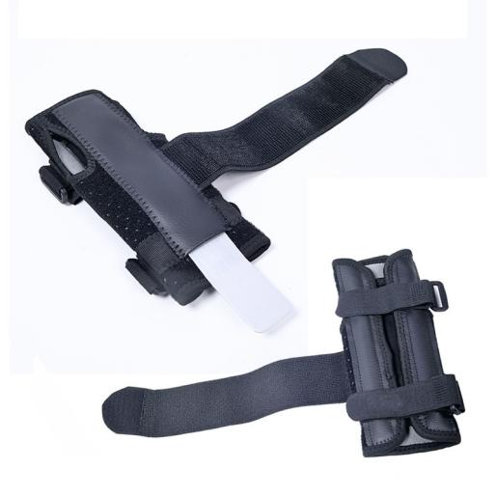

Wrist Supports for both left and right hands. Made of tough protection pads, this gloves provide protection of your hand and wrist, helps relieve pain and swelling and bring you the best palm padding possible.Adjustable straps for customer fit, provides the best wrist support while maintaining full range of movement of thumb and fingers.

**Common Examples of Use**

Running, fitness equipment, health massage, fitness and body beauty, cycling, martial arts and self-defense

**Product Features**

Wrist steel plate design

Triple wrist fixation

Uniform for both hands

Back ventilation holes