

Silicone ankle support for men and women

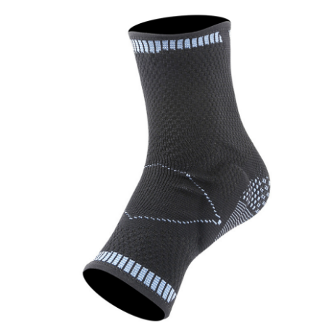

Item No: AK10

Material: Nylon, Spandex

Size:S M L

Color: Black,Blue,Green

Packing: 1 piece / opp bag,100 pcs/carton

The ankle brace is designed with corresponding silicone pads based on the inner and outer ankles to accurately protect the joints and share the load on the ankle bones. Different weaving densities are used in different parts to achieve segmented pressure. It fits the foot shape, is comfortable to wear, and allows unrestrained exercise.

**Common Examples of Use**

Badminton, basketball, cycling, mountain climbing, fitness, running, tennis.

**Product Features**

Elastic hem does not curl, does not squeeze the legs to prevent slipping during exercise.

Innovative light and breathable material with appropriate pressure to prevent sprains.

Highly elastic knitted fabric is not easy to deform and durable.

Silicone anti-collision protects joints and shares pressure.

**Size Chart**

