

Compression strap sports ankle support

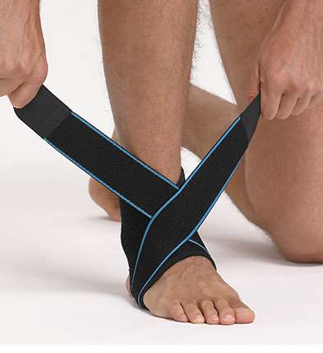

Item No: AK19

Material: OK cloth

Size:one size fits all

Color: Black

Packing: 1 piece / opp bag,100 pcs/carton

Neoprene material, pressure protection bandage fully wrapped double pressure elastic breathable, effectively protect the ankle joint. You can enjoy sports, exercise, running. You won't feel over tight or burdened when wearing them

**Common Examples of Use**

Suitable for ankle protection and protection during sports and daily life

**Product Features**

Bandage pressure fixation, figure eight wrap pressure can freely adjust the tightness

Wrap-around protection is strong and durable, wrap-around ankle protection is more fitting, strong wrapping, firm and durable

Breathable fabric, firm fit, not easy to pilling, good elasticity, wear resistance, strong and durable

Heel opening design is more comfortable, does not hurt the foot and is easy to wear