

Neoprene sports ankle support

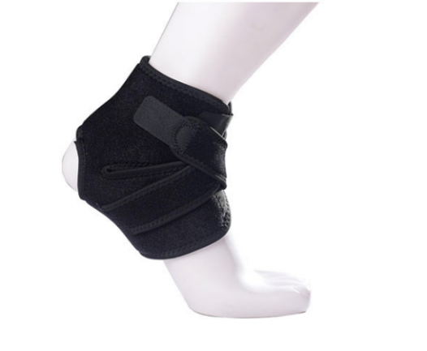

Item No: AK06

Material: Neoprene

Size:one size fits all

Color: Black

Packing: 1 piece / opp bag,100 pcs/carton

Open heel design allows wide range of motion during activity and still provide support for the ankle tendons and joints. Ideal for indoor and outdoor sports that need strain ankles during exercise.Breathable neoprene material retains heat and prevents skin irritation. Comfortable, flexible, durable and washable.

**Common Examples of Use**

Running, fitness, badminton, basketball, cycling,Protect everyone who loves sports.

**Product Features**

Velcro: No pilling after thousands of times of pasting, durable and long-lasting.

Even and tight stepping on the line, even force, no tiring walking.

Protect ankles, disperse pressure, no foot pain.

Free adjustment, easy to wear.

**Size Chart**

