

Sports compression ankle support

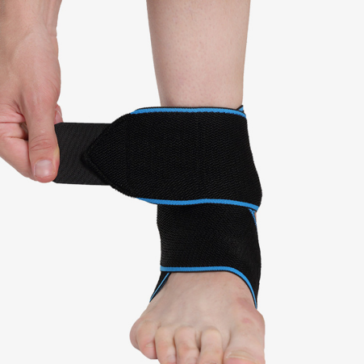

Item No: AK08

Material: Spandex

Size:one size fits all (8*90cm)

Color: Blue,Orange,Green,Gray,Red

Packing: 1 piece / opp bag,250 pcs/carton

High quality elastic nylon material was used, it fit different size foot, left and right feet are the same.We use silicone in side, add the friction, so that non-slip.Easy-to-use crisscross strapping attaches anywhere along the entire sleeve.

**Common Examples of Use**

Sports,plantar fasciitis, sprained ankles, swelling, achilles tendon support, minor ankle injuries and more

**Product Features**

Breathable & elastic materials that provide comfort all day.

Non-slip silicone inside ensures a tight grip.

Ankle compression helps reduce swelling and the pain associated with overuse or injury.